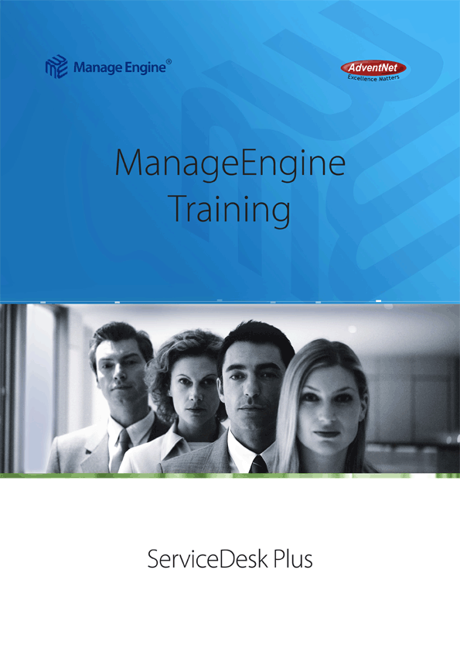

ManageEngine ServiceDesk Plus Training

Course Objectives

Who Should Attend

Course Agenda

Course Objectives
ServiceDesk Plus Training helps IT Managers, Administrators, and staff to get a head start in understanding and implementing an effective IT Help Desk Solution. At the end of the course, you will be able to
- Set up Incident and Problem management
- Define Change Management
- Discover and manage assets
- Enable a self-service and knowledge management portal
- Manage Software and Hardware inventory
- Handle Purchase and Contract management

Who Should Attend
- IT Help Desk Managers looking forward to optimize and streamline IT Support Operations
- IT Help Desk Administrators responsible for managing service levels by efficiently managing requests and IT Support Staff
- IT Support Staff

Course Agenda
- Introduction to Service Desk Plus
  - ServiceDesk Plus Overview
  - Benefits of a Service Desk Plus
  - Import requestors
  - Define Support Staff Roles
  - Creating Technicians
Implementing ServiceDesk Plus in your Organization
  - Organizational details
  - Define Locations, Department, Operational Hours, and Holidays
  - Channels of Support
    - Email / Intranet website / Phone
  - Problem Types – Categories
  - Levels – Tier 1, Tier 2 etc.
  - Any other Additional info
  - Customizing the Request form
  - Creating the Product Catalog
  - Creating a Vendor Database
Incident Management
  - Request Tracking
  - Automate with Business Rules
  - Request Escalation using SLA
  - Queues
  - Configure Notifications
  - Time-Tracking
Problem Management
- Problem Detection & Classification
- Problem Priority
- Problem Analysis
- Solutions, Work Around, and Known error record
- Problem Closure
Change Management
- Initiate Change Request
- Change Plans and CAB (Change Advisory Board)
- Approval from CAB Members
- Co-ordinate Change Implementation
- Post Implementation Review
- Change History
CMDB
- Discover Assets
- Detailed Asset Inventory
- Software Library
- Asset Relationships
Typical Helpdesk Workflows
- User calling in
- Self-Service Portal
- Email
Knowledge Management
- Solutions Database
- Public and Private solutions
Self Service Portal
- Creating a New Request
- Checking Status of previous Requests
- Searching Solutions
- Updating Contact Details
- Announcements
Hardware and Software Inventory
- Windows Domain Scan
- Network Scan
- Schedule Periodic Audits
- Software License Compliance
- Manage hardware inventory
Purchase Management & Contract Management
- Purchase cycle overview
- Create POs
- Submit for Approval
- Accept / Reject PO
- Approved POs to vendors.
- Receive or Partially receive Items
- Contracts Management
- Track & Manage Contracts from multiple vendors
Survey
- Define Survey and satisfaction levels
Reports
- Report Dashboards, Graphs, and Technician queues
- Technician and Time based Reports
- Category based Reports
- SLA violation Reports
- Pending, Completed, and Overdue Request Reports
Periodic Backups
- Configure and schedule Backups

Signup for the Classroom Training, or book for an Onsite Training now!

